**PIZZA SALES SQL QUERIES**

1. **Total Revenue**

**2. Average Order Value**



1. **Total Pizza Sold**

1. **Total Orders**

1. **Average Pizzas Per Order**



1. **Daily Order Trend**



1. **Monthly Order trend**

1. **Percentage of Category Sales**



1. **Percentage of Sales By Pizza size**

SELECT pizza_size, SUM(total_price)*100/(SELECT SUM(total_price) FROM pizza_sales ) AS Pecentage_of_Sales

FROM pizza_sales

GROUP BY pizza_size;

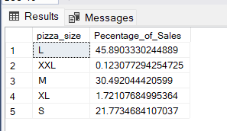

1. **Total Pizzas Sold by Pizza Category**

SELECT DISTINCT pizza_category, SUM(quantity)

FROM pizza_sales

GROUP BY pizza_category;

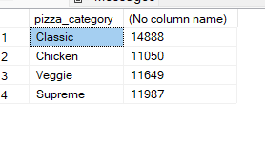

1. **Top 5 Pizzas by Revenue**

SELECT TOP 5 pizza_name, SUM(total_price) AS Total_revenue

FROM pizza_sales

GROUP BY pizza_name

ORDER BY Total_revenue DESC;

1. **Bottom 5 Pizzas by Revenue**

SELECT TOP 5 pizza_name, SUM(total_price) AS Total_revenue

FROM pizza_sales

GROUP BY pizza_name

ORDER BY Total_revenue ASC;

